EXERCISE PHYSIOLOGY PRACTICUM

Record of Student Engagement (RSE)

Note: A separate form must be completed for every placement site.
Name of Student:
Name of Placement Site:
Date Commenced: |  | Date Completed:

Provide a summary of hours allocated to areas of practice:
Please refer to appendix for areas of practise examples.
Core: |  | Emerging:
Niche: |  | Other:
Total Hours at Placement Site:

Provide an overview of your time on placement
- Describe the clientele worked with (age ranges, gender, reasons for service provision, client goals)
- How did you spend your time at this site?
Summary:

Provide a summary of activities undertaken.
Please refer to the ESSA Practicum Standards for further information.
Exercise Assessment
Please provide specific examples highlighting a range of exercise assessments completed.
- What subjective and objective assessments did you complete?
- How did you interpret these assessments?
Summary:

Exercise Prescription:
Please provide specific examples of exercise prescription completed.
- How did your assessment interpretation inform your prescription?
- How were the FITT principles applied?
- What exercises did you select and why?

Summary:

Exercise Delivery:
Please provide specific examples of exercises delivered in-person or via telehealth.
- What specific exercises/ types of exercise were delivered (including FIIT principles)?
- How did you progress/regress or adapt the program delivered to the client?
- What cues or technique corrections did you use?

Summary:

Other:
Please provide specific examples of other activities completed that are within the scope of an Accredited Exercise Physiologist (AEP).
- How did these activities fall within the scope of an AEP?
Summary:

Accredited Exercise Physiologist - Professional Attributes
Please tick the professional attributes this placement site has helped you develop.
Integrate knowledge and skills of AEP practice to design and deliver a broad range of health care services and adapt these into emerging areas.
Use critical thinking to analyse and solve problems across the scope of AEP practice and adapt to change.
Assess risks, capacity, and function and stratifies and applies appropriate risk management strategies.
Prescribe, implement, and evaluate safe and effective movement, physical activity, and exercise-based interventions for clients across the full health spectrum to optimise function, facilitate recovery, and maximise independence and participation in activities at home, school, work, and in the community.
Apply behavioural change principles to support treatment and management to prevent and minimise impairments, limitations, and activity restrictions associated with health conditions.
Communicate effectively and respectfully with clients and supports person-centred care through shared decision-making, and maintains accurate, timely, and appropriate documentation and records of services.
Practice ethically, collaboratively, and innovatively within the scope of AEP training.
Collaborate effectively and respectfully with relevant others involved in the client’s health and well-being including delegating tasks, referring, and working in partnership with other professionals and services where appropriate.
Display professional conduct, decision-making, and person-centred care that is consistent with the ESSA Code of Professional Conduct and Ethical Practice [2] and other codes of conduct, legislation, and standards that apply to their practice.
Apply evidence-based practice to compile and critically evaluate scientific rationale for professional decision-making, service delivery, and evaluation of interventions and their outcomes.
Commit to professional self-development in the field of AEP practice through educational engagement and ongoing learning, self-reflective practice, interprofessional collaboration, and innovative practice.
Practice in a safe, respectful, and inclusive way that is responsive to people of diverse backgrounds and populations, including Aboriginal and Torres Strait Islander peoples; people with diverse genders, relationships, identities, and sexualities; culturally and linguistically diverse backgrounds; those with a disability; and other groups experiencing inequity
Apply appropriate digital practices including critically analysing choice of technology across service delivery such as telepractice/telehealth.
Exhibit professional leadership in all aspects of practice including advocating for access to health care services and AEP services and contributing to education and professional practice development of peers and students.

How did this placement site assist you in developing these professional attributes?
Please select three attributes from the table above and provide examples.
Summary:

Supervisor Declaration and Signature
(To be signed within one month of completing placement)
Name:
Relevant Qualification (Year of Completion): | For example, Bachelor of Exercise Science (2015), Master of Clinical EP (2020)
If you are not an ESSA accredited health professional, please provide a summary of experience relevant to the activities you have supervised:
For example, Physiotherapist with 4 years of experience in musculoskeletal assessment and rehabilitation.

I have read the information contained within this Record of Student Engagement and certify that this is a true and accurate reflection of the applicant’s engagement at this placement site.
Signature:
Date:

Practicum Coordinator’s Signature (to be signed after the record of student engagement has been signed by the practicum supervisor).
Coordinator’s Name:
Coordinator’s Signature:
Date signed:

Appendix:

Example Areas of Practice*

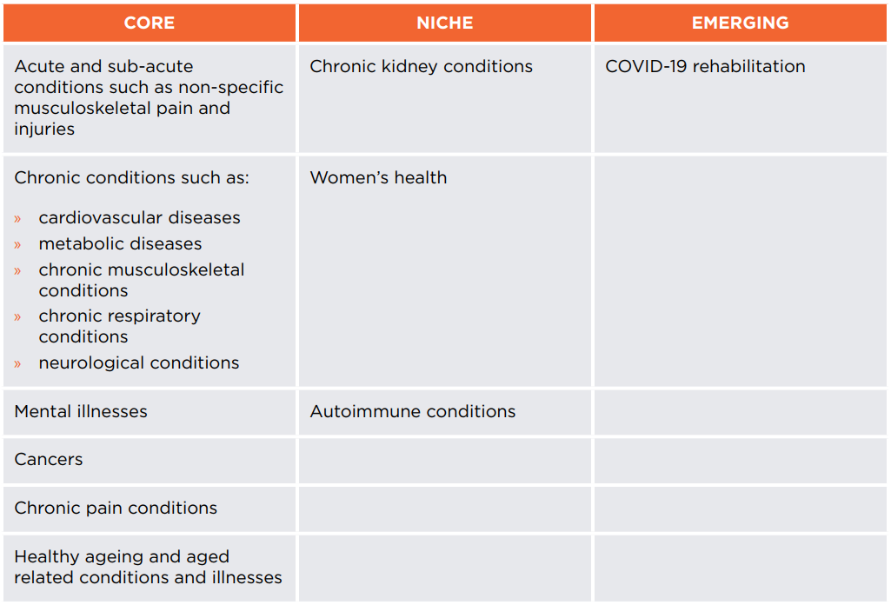

*This table provides examples of current areas of practice and is not an exhaustive list. The areas of practice are fluid and dynamic and will be reviewed after 12 months based on industry changes.

